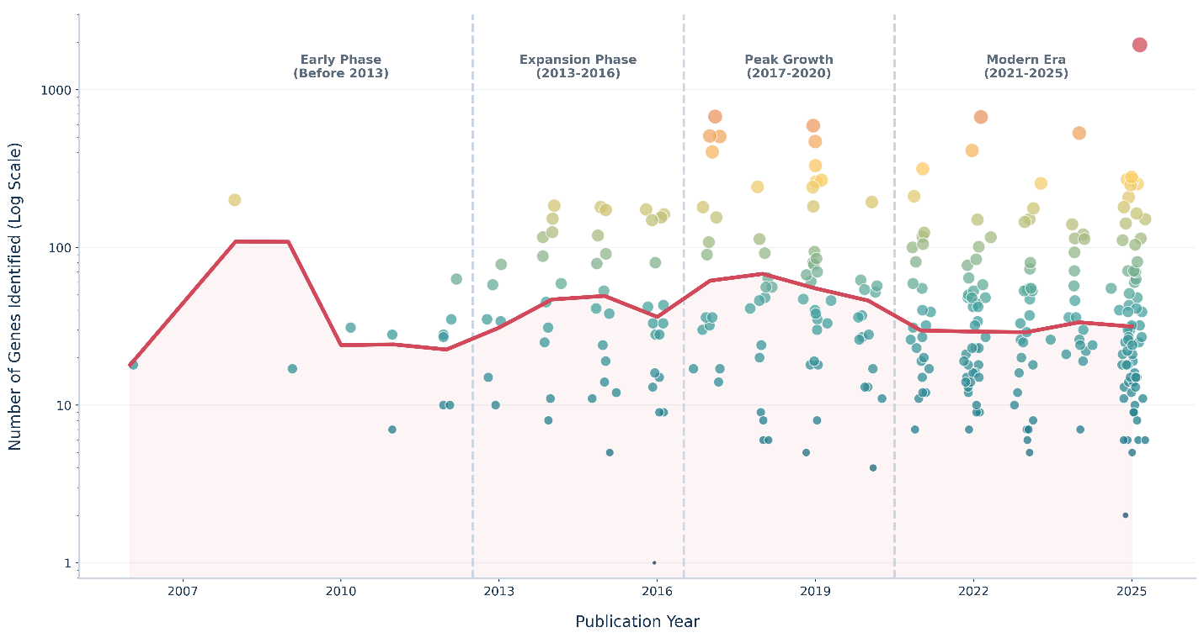
Figure 8. Temporal gene identification and family expansion. Chronomap represents the exponential increase in gene identification over time. Dots represent the individual studies published in the specific era and are mapped on a logarithmic scale to visualize the number of genes identified. The size of the dots represents the number of genes (log scale).

